Packet Tracer – Configuring RIPng

Topology

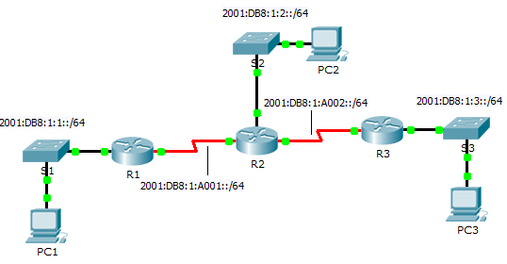

1. Addressing Table

|  |  |  |
| --- | --- | --- |
| Device | Interface | IPv6 Address/Prefix |
| R1 | G0/0 | 2001:DB8:1:1::1/64 |
| S0/0/0 | 2001:DB8:1:A001::1/64 |
| R2 | G0/0 | 2001:DB8:1:2::1/64 |
| S0/0/0 | 2001:DB8:1:A001::2/64 |
| S0/0/1 | 2001:DB8:1:A002::1/64 |
| R3 | G0/0 | 2001:DB8:1:3::1/64 |
| S0/0/1 | 2001:DB8:1:A002::2/64 |

Objectives

Part 1: Configure RIPng

Part 2: Verify Configurations and Connectivity

1. Background

RIPng (RIP Next Generation) is a distance vector routing protocol for routing IPv6 addresses. RIPng is based on RIPv2 and has the same administrative distance and 15 hop limitation. This activity will help you become more familiar with RIPng.

1. Configure RIPng
   1. Configure RIPng on R1.
      1. Enable IPv6 routing on **R1**.

R1(config)# **ipv6 unicast-routing**

* + 1. Enter RIPng protocol configuration mode.

R1(config)# **ipv6 router rip CISCO**

* + 1. Enable RIPng for the networks that connect to **R1**.

R1(config-rtr)# **int g0/0**

R1(config-if)# **ipv6 rip CISCO enable**

R1(config-if)# **int s0/0/0**

R1(config-if)# **ipv6 rip CISCO enable**

* + 1. Save the configuration.
  1. Configure RIPng on R2 and R3

Repeat Step 1a to Step 1d on **R2** and **R3**.

1. Verify Configurations and Connectivity
   1. View routing tables of R1, R2, and R3.
      1. Use the appropriate command to view the routing table for **R1**. RIPng (R) now appear with connected (C) and local (L) routes in the routing table. All networks have an entry.
      2. Verify that the appropriate interfaces are using RIPng.

R1# **show ipv6 protocols**

* + 1. View the running configuration of **R1**. RIPng entries are present.
    2. Repeat Step 1a to Step 1c with **R2** and **R3** to verify that they were properly configured.
  1. Verify full connectivity.

Every device should now be able to ping every other device. If not, review your configurations for errors and implement appropriate solutions.